Judith Barrios
ITAI-4370: AI 5/6G Communications & ORAN Networks
Conceptual Communication System Diagram and Signal Flow Analysis
Instructor: Tawanda Chiyangwa
June 6, 2026

Part 1: Conceptual Diagram
The diagram below represents the basic flow of a digital communication system using BPSK modulation. Starting from the left, the source block is where the original binary data is produced. Those bits are then passed to the modulator, which converts them into a signal that can be transmitted. As the signal travels through the channel, random noise is introduced, simulating the kind of interference that happens in real-world environments. On the receiving end, the demodulator analyzes the noisy signal and makes a decision on what the original bits were, and the receiver outputs the recovered data.
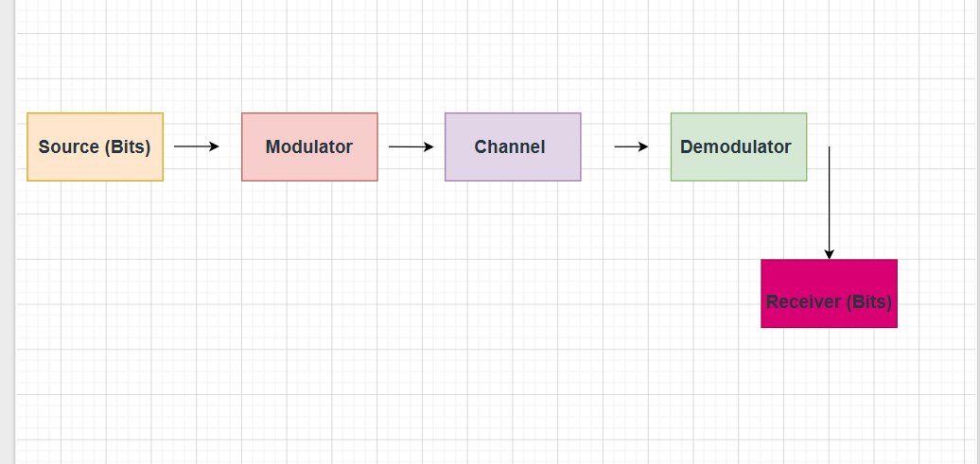

Part 2: Signal Flow Analysis in Python
Python Code:
import numpy as np
import matplotlib.pyplot as plt
from scipy.special import erfc

# number of bits to simulate
N = 100000

# SNR range (0 to 14 dB)
EbN0_dB = np.arange(0, 15)
EbN0_lin = 10 ** (EbN0_dB / 10.0)

# theoretical BER for BPSK
ber_theory = 0.5 * erfc(np.sqrt(EbN0_lin))

# simulate the signal flow for each SNR value
ber_sim = []

for snr in EbN0_lin:
# source - generate random bits
bits = np.random.randint(0, 2, N)

# modulator - BPSK maps 0 to -1 and 1 to +1
symbols = 2 * bits - 1

# channel - add gaussian noise
sigma = np.sqrt(1 / (2 * snr))
noise = sigma * np.random.randn(N)
received = symbols + noise

# demodulator - decision: if received > 0, decide bit = 1
detected = (received > 0).astype(int)

# receiver - count errors
errors = np.sum(bits != detected)
ber_sim.append(errors / N)

# plot BER vs SNR
plt.figure(figsize=(8, 5))
plt.semilogy(EbN0_dB, ber_theory, 'b-', label='Theoretical BER')
plt.semilogy(EbN0_dB, ber_sim, 'ro--', label='Simulated BER')
plt.xlabel('Eb/N0 (dB)')
plt.ylabel('Bit Error Rate (BER)')
plt.title('BPSK Signal Flow - BER vs SNR')
plt.legend()
plt.grid(True)
plt.show()
Matplotlib Output Plot:
The plot shows the Bit Error Rate (BER) versus Signal-to-Noise Ratio (Eb/N0) for a BPSK system. The blue line is the theoretical BER and the red dots are the simulated BER. As SNR increases, BER drops significantly, meaning fewer bits arrive corrupted at the receiver. The simulated results closely match the theoretical curve, which confirms the signal flow model is working correctly.

